

Co-operative Master’s Programme

Electronic Engineering and Computer Science: 2014/15

• Study in London for a year

• Receive both an NUPT Master’s degree and a QMUL Master’s degree

• Scholarships for all NUPT students

• Immerse yourself in UK culture and greatly improve your English Language skills

• Guaranteed accommodation on campus for all NUPT students

• Airport Pick-up and Welcome Week along with other international students

• Become a global citizen and make life-long contacts from all over the world

|  |  |
| --- | --- |
| Year 1 at NUPT: | Year 2 at QMUL: |
| Computer Science and Technology | MSc Computer Science |
| MScR Computer Science (by Research) |
| MSc Computer Vision |
| MSc Computing and Information Systems |
| Software Engineering | MSc Software Engineering |
| Information and Communication Engineering | MSc Digital Signal Processing |
| MSc Telecommunication Systems |
| Electronic Science and Technology | MScR Electronic Engineering (by Research) |
| Optical Engineering |
| Instrument Science and Technology |





QMUL Programme Overviews

QMUL Application

MSc Computer Science:

This multidisciplinary programme prepares you for a wide range of careers depending on which modules you select. Typical careers after graduation include advanced programmer, software development and support, software engineer, product designer/developer, systems analyst, interface/interaction designer, database developer and other specialist employment based on your selected study areas. [www.eecs.qmul.ac.uk/postgraduates/programme/view/685](http://www.eecs.qmul.ac.uk/postgraduates/programme/view/685)

MSc Computer Vision:

Intended to create researchers and industry engineers with a high level of training in analysis and interpretation of images and video. Covers both low-level image processing and high-level interpretation using state-of-the-art machine learning methodologies. In addition, we offer advanced training in programming languages, tools and methods that are necessary for the design and implementation of practical computer vision systems. [www.eecs.qmul.ac.uk/postgraduates/programme/view/685](http://www.eecs.qmul.ac.uk/postgraduates/programme/view/685)

MSc Computing and Information Systems:

An intensive programme for students without much experience of computer science. You will develop theoretical and practical skills in computing & information systems development, including an introduction to core aspects of computing, and using Java, plus modules covering Systems Analysis and Software Engineering. Optional specialist modules cover a broad range of subjects relevant to the software industry, such as Network Programming, Business Information Systems and Graphical User Interface design. [www.eecs.qmul.ac.uk/postgraduates/programme/view/21](http://www.eecs.qmul.ac.uk/postgraduates/programme/view/21)

MSc Software Engineering:

Focuses on advanced theoretical and practical techniques in program design, and the management of software project risk. Includes training in vital areas such as security, specification, risk management, usability, and design integrity. You will learn advanced techniques in program design and information handling. You can study key issues of interactive system design, leading to identifying issues and trade-offs in the design of human-computer interaction, and to invent solutions to design problems. You will gain knowledge in the mathematical foundations of software and the practical application of these techniques.

[www.eecs.qmul.ac.uk/postgraduates/programme/view/60](http://www.eecs.qmul.ac.uk/postgraduates/programme/view/60)

MSc Digital Signal Processing

Intended to create industry engineers with a high level of training in signal processing, and to support Internet, multimedia, broadcast, communications, and consumer industries. You will develop core knowledge of basic DSP theory and its implementation in hardware. In addition to specialising in areas including multimedia and intelligent signal processing. The taught modules are fully supported, with computing and laboratory work.

[www.eecs.qmul.ac.uk/postgraduates/programme/view/67](http://www.eecs.qmul.ac.uk/postgraduates/programme/view/67)

MSc Telecommunication Systems

This programme provides training in the principles and applications of telecommunications through an integrated curriculum designed to respond to rapid developments and growing demands. It emphasises both the underlying technologies and the techniques required for their analysis and understanding. You will understand how different infrastructures and designs affect commercial decisions.

[www.eecs.qmul.ac.uk/postgraduates/programme/view/385](http://www.eecs.qmul.ac.uk/postgraduates/programme/view/385)

MScR Electronic Engineering (by Research)

An MSc by Research will provide you with the skills to undertake research, either in an academic or industrial environment. The expectation is that every graduate from the degree publishes at least one conference paper as part of the research. You will have the opportunity to develop further research and technical skills and demonstrate a greater level of independence. The programme is suitable for outstanding students who have an interest in advanced research-based study in one of our research specialisms: Antenna and Electromagnetics; Centre for Digital Music (C4DM); Multimedia and Vision (MMV); Networks.

[www.eecs.qmul.ac.uk/postgraduates/programme/view/114](http://www.eecs.qmul.ac.uk/postgraduates/programme/view/114)



**Entry Requirements:**

Students must have achieved a minimum academic grade of 70 in their first year at NUPT and achieve a minimum of IELTS 6.5 or IBTOEFL 92 to be considered for QMUL in Year 2.



**1. Making your application**

Students should apply online through the QMUL website. Go to [www.eecs.qmul.ac.uk](http://www.eecs.qmul.ac.uk)/postgraduate/programme, and select your desired MSc course, click on the “Apply Now” tab and begin to complete your details.

In the section that says Agent Details (as below), please select ‘Yes’ and find Nanjing University of Posts and Telecommunications in the drop-down box. You will also need to upload supporting documents.

Once you have made your application, please send an email to [international-partnerships@qmul.ac.uk](mailto:international-partnerships@qmul.ac.uk%20) stating your full name and that you are from NUPT.

THE DEADLINE FOR APPLICATIONS IS THE 23RD MARCH

**2. Receiving your offer**

• Offers will be made through the main Admissions

Office at QMUL, with the aim for students to be informed 2 weeks after their application, provided all documents have been received.

• You will be given either an unconditional offer if you already meet the entry requirements or a conditional offer on the condition that you achieve the correct academic grades/English language grades before you begin the programme at QMUL

• You will be asked to **accept your place, and later to request your CAS number** – please do so as soon as possible. You should also make sure you read all emails from QMUL in detail.

**3. Apply for your accommodation**

• After you accept your place, you will be given a QMUL username and password and the link to apply for your housing. Once you have submitted this you will receive a confirmation email from Residential Services.

• Please make your application as soon as possible.

THE DEADLINE FOR HOUSING APPLICATIONS IS THE END OF MAY

**4. Apply for your visa**

• The visa application process may take up to three months, so it is always good to apply well in advance. Check the UKBA website for information on Tier 4 Adult students: [www.ukba.homeoffice.gov.uk](http://www.ukba.homeoffice.gov.uk)

• You should have achieved and sent us your English Language certificate by the end of May at the latest.

• You must also prove to UKBA that you have had the necessary finances to study in the UK in your bank account for at least 28 days before your visa application – more details on the UKBA website.

• Once you have sent us all the necessary transcripts and received your unconditional offer, you can apply for your visa using the CAS (Confirmation of Acceptance for Studies) number. You must have your original documentation that was used for your application – original letters, transcripts, etc.

**5. Prepare for your arrival!**

• We will send you lots of information by email, so please make sure you read it all thoroughly.

• Everything you need to know before you get here is detailed on our website: [www.qmul.ac.uk/prearrival](http://www.qmul.ac.uk/prearrival)



**Contacts at NUPT:**

张舒

Department of International Cooperation and Exchanges

Email: [zhangshu@njupt.edu.cn](mailto:zhangshu@njupt.edu.cn)

Tel: +86 25 85866245

Finances

**Programme Cost:**

Degree per year: £15,950

**Scholarships for NUPT students:**

Students with an average academic grade

of 70% will be given a Scholarship of £2,000

Students with an average academic grade

of 85% will be given a Scholarship of £5,000

**Living Expenses:**

Accommodation on campus: From £120 - £160 per week for 38 weeks.

Travel: A weekly student travel pass costs £21.20

Food: Most QMUL students spend around £50 per week on food.

Total: About £1,000 per month

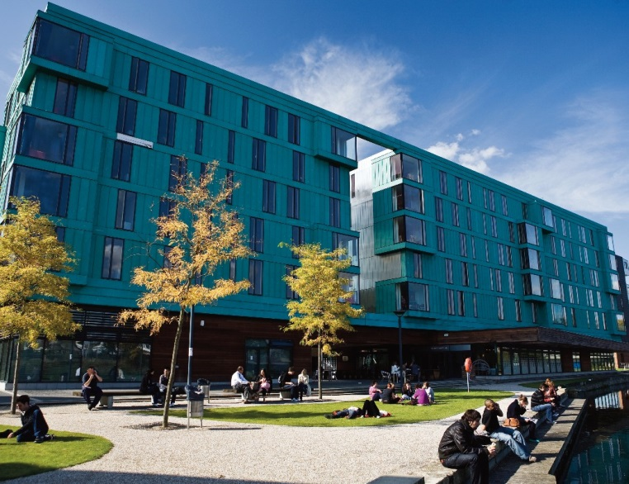

Partner Student Profile:

**冯健龙 - Feng Jianlong – MRes Electronic Engineering**

I wanted to study at QMUL because it is a member of the University of London system, which is prestigious not only in UK but also around the world. As a student majoring in Electronic Engineering, I greatly care about the Research Assessment Exercise. QMUL is ranked as 11th which is very high. Considering these two factors I believe that QMUL is an excellent place to study.

There are many activities at QMUL, both academic ones and social ones. Since London is a metropolis as well as the Capital of UK, it provides me with a profound insight into both the cultural atmosphere of the UK and the culture blending of the World. There are many international students in QMUL which enables me to learn good qualities from other people.  
  
The QMUL campus has a very different atmosphere to my university in China and it would be wise for students from partner institutions to learn more social skills and be more open-minded before they come to QMUL.



Useful Links

**Advice for QMUL international students:**

[www.qmul.ac.uk/international](http://www.qmul.ac.uk/international)

**Accommodation:** [www.residences.qmul.ac.uk](http://www.residences.qmul.ac.uk/)

**Before you arrive:** www.qmul.ac.uk/prearrival

**Visa advice:** [www.ukba.homeoffice.gov.uk/](http://www.ukba.homeoffice.gov.uk/)

visas-immigration/studying/adult-students

**Safety in the UK:** [www.britishcouncil.org/](http://www.britishcouncil.org/)

eduk-comfort-zone.pdf

**Things to do in London:** [www.timeout.com/london](http://www.timeout.com/london)

**National Union of Students:** [www.nus.org.uk](http://www.nus.org.uk/)